Project Design Phase-II
Technology Stack (Architecture & Stack)

Date | 31 January 3035
Team ID | 6ab3d8050fc666a751b367a2
Project Name | AI studybuddy
Maximum Marks | 4 Marks

Technical Architecture
Project Title: AI StudyBuddy – AI-Based Study Planning and Learning Assistance Application
The technical architecture describes the structure, components, technologies, and interactions of the AI StudyBuddy application. It combines a user interface, application logic, database, AI service, and Weather API to provide students with study assistance, study planning, task management, and weather updates.
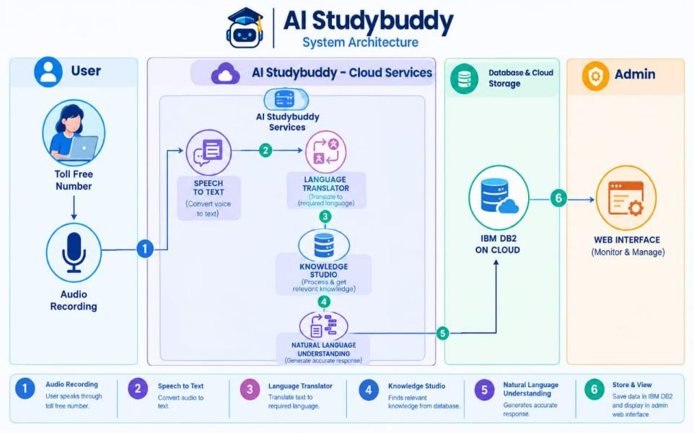
Guidelines:
Include all the processes (As an application logic / Technology Block)
Provide infrastructural demarcation (Local / Cloud)
Indicate external interfaces (third party API’s etc.)
Indicate Data Storage components / services
Indicate interface to machine learning models (if applicable)

Table-1 : Components & Technologies:
S.No | Component | Description | Technology
 | User Interface | Provides a simple interface for students to register, log in, manage study schedules, ask AI questions, and view weather information. | HTML, CSS, JavaScript / Angular Js / React Js etc.
 | Application Logic-1 | Handles user registration, login, authentication, and session management. | Python, Flask
 | Application Logic-2 | Logic for a process in the application | IBM Watson STT service
 | Application Logic-3 | Logic for a process in the application | IBM Watson Assistant
 | Database | Data Type, Configurations etc. | MySQL, NoSQL, etc.
 | Cloud Database | Database Service on Cloud | IBM DB2, IBM Cloudant etc.
 | File Storage | File storage requirements | IBM Block Storage or Other Storage Service or Local Filesystem
 | External API-1 | Purpose of External API used in the application | IBM Weather API, etc.
 | External API-2 | Purpose of External API used in the application | Aadhar API, etc.
 | Machine Learning Model | Purpose of Machine Learning Model | Object Recognition Model, etc.
 | Infrastructure (Server / Cloud) | Application Deployment on Local System / Cloud  Local Server Configuration:  Cloud Server Configuration : | Local, Cloud Foundry, Kubernetes, etc.

Table-2: Application Characteristics:
S.No | Characteristics | Description | Technology
 | Open-Source Frameworks | The application uses open-source technologies to develop the user interface, backend logic, and database connectivity. | Python, Flask, HTML, CSS, JavaScript, MySQL
 | Security Implementations | User passwords should be securely hashed. Input validation, authentication, session management, and protected API keys should be used to protect user data and external services. | Password hashing, Flask sessions, input validation, HTTPS, environment variables
 | Scalable Architecture | Justify the scalability of architecture (3 – tier, Micro-services) | Technology used
 | Availability | Justify the availability of application (e.g. use of load balancers, distributed servers etc.) | Technology used
 | Performance | Design consideration for the performance of the application (number of requests per sec, use of Cache, use of CDN’s) etc. | Technology used

